O
Dimensions in Inches, Tolerances: .XX ± .03 .XXX ± .010
DC CURRENT TRANSDUCER

SERIES S966

REMOVEABLE YOKE TYPE

PART CURRENT PART CURRENT NUMBER RANGE NUMBER RANGE
S966-500 0 to 500 S966-750 0 to 750
S966-1000 0 to 1000 S966-1500 0 to 1500
S966-2000 0 to 2000 S966-2500 0 to 2500
S966-3000 0 to 3000 S966-3500 0 to 3500
S966-4000 0 to 4000 S966-5000 0 to 5000

INPUT CURRENT
RANGE Adc (See Table)
OVERLOAD 10kAdc

OUTPUT
VOLTAGE SIGNAL 0 to 5Vdc FS (Full Scale)
ACCURACY (Over Temperature Range) %1 FS
RESPONSE (10 to 90%) 200 u-sec. max.
OUTPUT IMPRDANCE 20 Ohms max.
VOLTAGE SIGNAL @ OVERLOAD 6.5Vdc typ.
PROTECTION Short CKT.

POWER SUPPLY
SUPPLY VOLTAGE +11Vdc to +32Vdc
CURRENT DRAIN 20mAdc max.
PROTECTION Reverse polarity protected
TRANSIENT PROTECTION ±40V (T<10mS)

ENVIRONMENTAL AND PHYSICAL CHARACTERISTICS
OPERATING TEMPERATURE RANGE -40° to +85°C
STORAGE TEMPERATURE RANGE -45° to +91°C
HUMIDITY (Operating) 0% to 95%RH
ISOLATION Input to output 5Kv RMS 60Hz
SHOCK 50g 11m-sec. half sine pulse
INSULATION RESISTANCE 500 M-Ohms @ 500Vdc
DIELECTRIC STRENGTH 5Kvac rms input to output
CASE MATERIAL Molded Plastic meets UL flammability
rating 94V-O (color light gray)
WEIGHT 24 oz. Max.

NOTE: INTERNAL CIRCUITRY SEALED MAKING TRANSDUCER WATER SPRAY RESISTANT
YOKE CAPTIVE SCREWS: 8-32 SLOT
TORQUE: 2 IN-LB CAUTION DO NOT EXCEED
SCREWDRIVER: 7/32” SLOTTED HEAD
1 ½” MIN SHAFT LENGTH

Drawing Number Rev.

700-S966 B
AAC
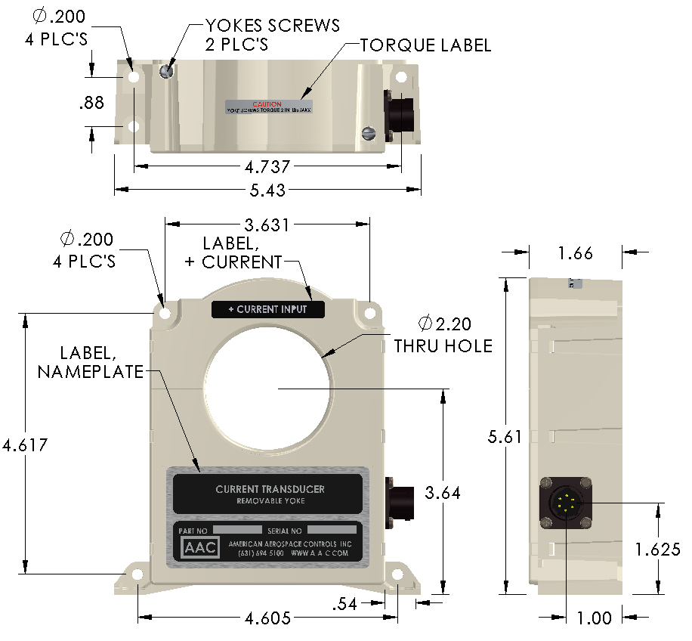

YOKE CAPTIVE SCREWS: 8-32 SLOT
TORQUE: 2 in-lb CAUTION DO NOT EXCEED.
SCREWDRVIER: 7/32” SLOTTED HEAD
1½” MIN SHAFT LENGTH
RECOMMENDED MOUNTING SCREWS: 10-32 x ¼” MIN;
TORQUE: 5lb-in; FLAT AND LOCK WASHERS.

CONNECTOR
P/N PT02E-10-6P-023
MATING CONNECTOR
PT06-10-6S OR EQUIV

CONNECTOR

IDENTIFICATION
1. SIGNAL OUTPUT (+)
2. OUTPUT (RTN)
3. SUPPLY VOLTAGE (+)
4. SUPPLY VOLTAGE (RTN)
5. SPARE
6. SPARE
Terminal 2 & 4 are common

