Dimensions in Inches, Tolerances: .XX ± .03 .XXX ± .010
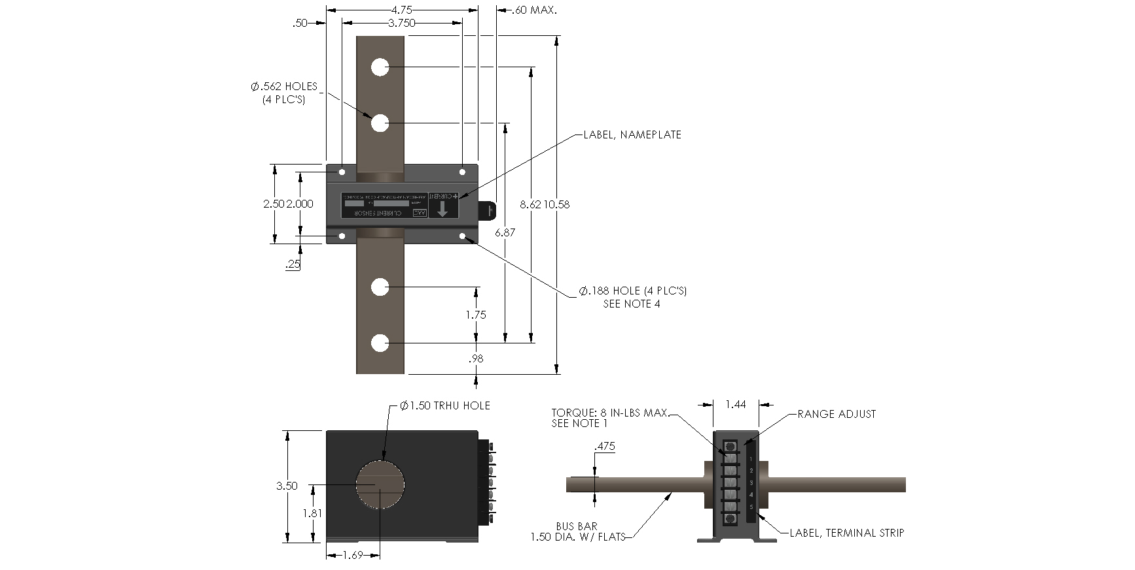
DC CURRENT LEVEL DETECTOR
PART NUMBER S680

INPUT
RANGE 0 to ± 1000Adc (Continuous)
OVERLOAD / TRANSIENT ± 2004A RMS (1 min)
± 1635A RMS (30 min)
± 2960A Peak (5 sec.)

TRIP POINT SETTING
SET POINT ±3Adc (±10%)
TRIP POINT DELAY (TYPICAL) 350 m-sec. After input (Absolute Value) Exceeds Trip Point
ADJUSTMENT RANGE Field Adjustable ±3 to ±5Adc

RESET POINT SETTING
RESET POINT……………………………. One Amp (Absolute Value) Below Trip Point
RESET POINT DELAY (TYPICAL)……... 10 Sec. After Input (Absolute Value) Decreases
Below Reset Point
OUTPUT RELAY (Solid State)
RELAY CONTACT (SPST) Contacts Close at and above trip point
CONTACT RESISTANCE On 25 Ohms Max, Off 500M Ohms Min.
DIELECTRIC STRENGTH 3.3KV RMS 60Hz
CURRENT LIMIT PROTECTION Automatically Limits Contact Current to 370mA
OPEN CIRCUIT VOLTAGE……………… 200Vdc OR Peak Max
DUTY CYCLE……………………………… Number Of “Change Of State” Operations Is Unlimited.
POWER SUPPLY
SUPPLY VOLTAGE +25 to 45Vdc
CURRENT DRAIN 25mA max.
TRANSIENT PROTECTION ±60V Peak (30sec.); ±100V Peak (2m sec.)

ENVIRONMENTAL AND PHYSICAL CHARACTERISTICS
OPERATING TEMPERATURE -25°C to +75°C
STORAGE TEMPERATURE -40°C to +85°C
SHOCK & VIBRATION IAW ADTRANZ Doc. ABB-ES-091291-1
OPERATING HUMIDITY 0 to 95% Relative Humidity
INSULATION RESISTANCE 500 M-ohms @ 500Vdc
DIELECTRIC STRENGTH 3.3Kv RMS 60Hz
PRIMARY BAR VOLTAGE 2Kv RMS max.
CASE Molded Plastic (GE Lexan) Meets UL
Flammability Rating 94 V-0
WEIGHT 6.5 lbs. max.

NOTE:

1. MOLDED TERMINAL BLOCK WITH 6-32 TERMINAL SCREWS, 3/8 IN.
CENTER TO CENTER SPACING. ACCEPTS WIRE SIZES TO 14 AWG
AND WIRE LUGS UP TO 9/32 IN. WIDE. TORQUE 8 IN-LB MAX.
2. REFERENCE DOCUMENT NO. E301-005.RFP (XIZ).
3. RECOMMENDED MOUNTING HARDWARE #8 SCREW, #8 SPLIT
LOCKWASHER AND #8 FLAT WASHER.
TORQUE MAXIMUM 18 IN-LB.
4. AVAILABLE WITH OR WITHOUT THE BUS BAR.
Drawing Number Rev.

700-S680 F

AAC
