Dimensions in Inches, Tolerances: .XX ± .03 .XXX ± .010

DC CURRENT LEVEL DETECTOR
SERIES S58-800

CURRENT ACTUATION LEVELS

ZERO CURRENT INPUT CONDITION A
200mA to 10A Max. CONDITION B

OUTPUT

CONDITION A (ZERO CURRENT) 1K-Ohm max. between terminal 1 & 2 CONDITION B (ABOVE 200mA) 40K-Ohm min. between terminal 1 & 2

EXCITATION VOLTAGE

VOLTAGE 28Vdc Nominal 22.8 to 30.4 Vdc min. to
max. voltage.

RESPONSE 1 m-sec. max.

ADJUSTMENTS None

RESET FROM COND. B TO COND. A Automatic when current levels falls within
0 to 200 mA.

ENVIRONMENTAL

TEMPERATURE RANGE 0°C to 70°C
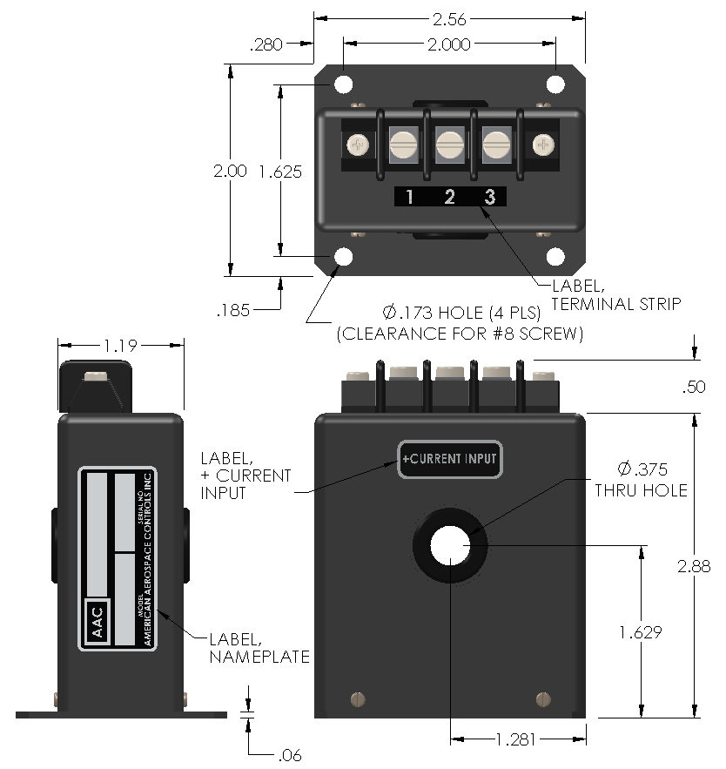
Drawing Number Rev.

700-S58-800 C
AAC

TERMINAL IDENTIFICATION

- +28Vdc EXCITATION VOLTAGE
- OUTPUT
- EXCITATION RETURN AND
OUTPUT RETURN (DC COMMON)
BARRIER BLOCK TERMINAL
6-23 TERMINAL SCREWS.

