AC VOLTAGE TRANSDUCER
SERIES 108

PART INPUT VOLTAGE CONTINUOUS
NUMBER RANGE Vac OVERLOAD Vac
108-50 0 to 50 100
108-130 0 to 130 180
108-150 0 to 150 200
108-270 0 to 270 380
108-300 0 to 300 410
108-500 0 to 500 700
108-600 0 to 600 800

INPUT
VOLTAGE RANGE See Table
FREQUENCY 60Hz (Optional Model Available) *
FREQUENCY RANGE 57 to 63Hz
BURDEN 3mA max.
OVERLOAD Vac See Table

OUTPUT
VOLTAGE SIGNAL 0 to +5Vdc FS (Full Scale)
4 to 20mA Output Models Available
ACCURACY ±0.5% FS (±25mV)
RESPONSE (0 to 90%) 300 m-sec max.
RIPPLE 25mV RMS max.
TEMPERATURE COEFFICENT ±0.02% FS/°C max.
REPEATABILITY ± 0.1% FS
OUTPUT IMPEDANCE 4000 Ohms max.

POWER SUPPLY
SUPPLY VOLTAGE Self excited

ENVIRONMENTAL AND PHYSICAL CHARACTERISTICS
OPERATING TEMPERATURE RANGE - 40° C to +85°C
STORAGE TEMPERATURE RANGE - 55°C to +85°C
INSULATION RESISTANCE 200 M-Ohms (all terminals to case)
MOISTURE RESISTANCE Will meet Method 106 of MIL-STD
-202 & Method 507.1, Proc.1 of
MIL-STD-810.
DIELECTRIC STRENGTH 1000V RMS
WEIGHT 10 oz. max.

Dimensions in Inches, Tolerances: .XX ± .03 .XXX ± .010

TERMINAL IDENTIFICATION

BARRIER CONNECTOR
1 AC VOLTAGE INPUT A
2 AC VOLTAGE INPUT B
3 OUTPUT (+) C
4 OUTPUT (RTN) D
SPARE E
CASE GROUND F

Drawing Number Rev.

700-108 R
AAC
TERMINAL SCREWS 5-40 3/8 CENTER TO CENTER
WIRE SIZES TO 14 AWG WIRE LUGS TO .281 WIDE.
* Optional Models
ADD SUFFIX -50 TO MODEL NO. FOR 50Hz OPERATION.
ADD SUFFIX -400 TO MODEL NO. FOR 400Hz OPERATION.
ADD SUFFIX –4000 TO MODEL NO. FOR 4000Hz OPERATION.
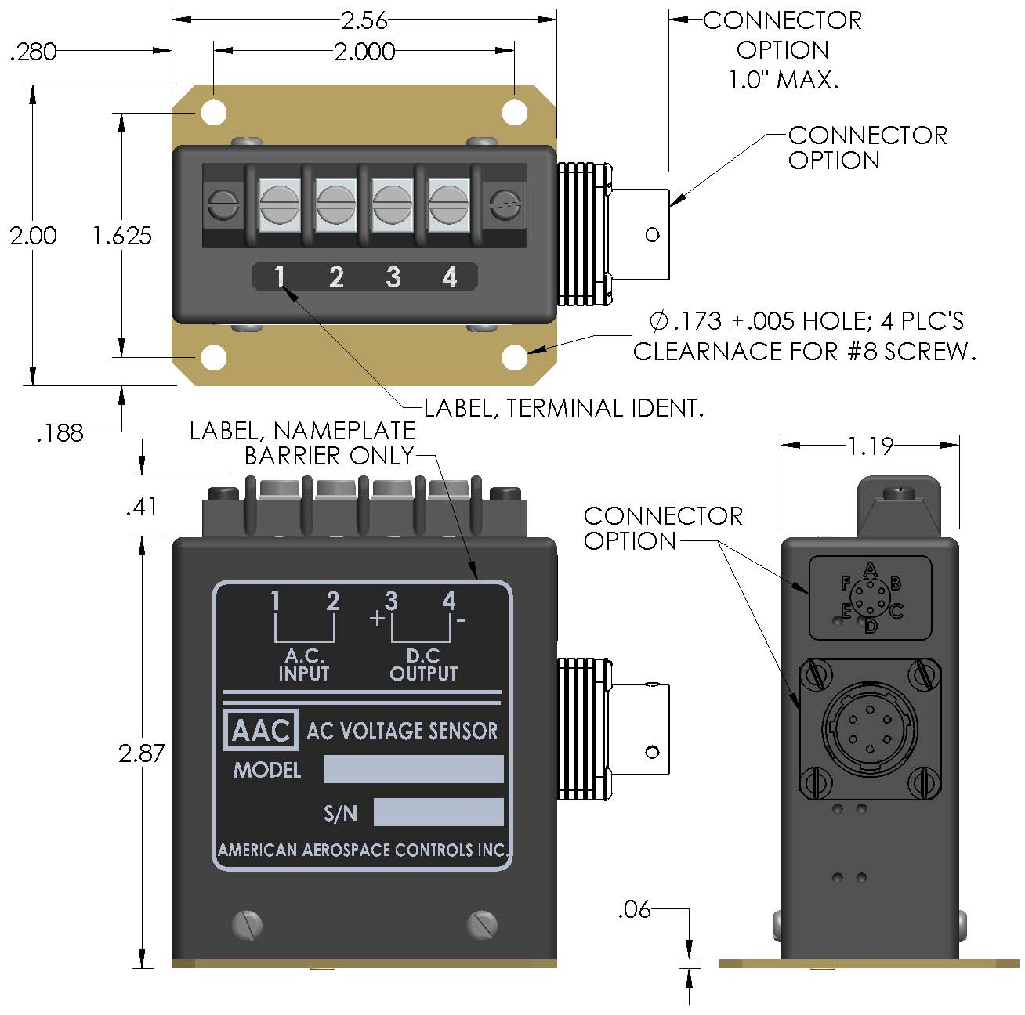
CONNETOR
OPTION
ADD “-C” TO
PART NO.
CONNECTOR P/N
PT02E-10-6P-023 OR EQUIV.
MATING CONNECTOR
PT06A-10-6S

