fo
Dimensions in Inches, Tolerances: .XX ± .03 .XXX ± .010

AC VOLTAGE SENSOR
MODEL 105

PRESET RANGE (V_{MAX} TO V_{MIN}) MODEL
390 to 490 VRMS -490
455 to 505 VRMS -505
430 to 530 VRMS -530
400 to 560 VRMS -560

INPUT LINE FREQUENCY 57 to 63Hz

EXCITATION Self-excited

BURDEN 1Va Typical

OUTPUT FOR PRESET RANGE 0 to 5Vdc

OUTPUT IMPEDANCE 3K Ohms Max.

RESPONSE Within 1 Cycle of Input Frequency

RIPPLE 50mV RMS

SUPPRESSION VOLTAGE ACCURACY ± .25% of V Min.

RANGE ACCURACY ± 0.5% F.S. Max.

TEMPERATURE COEFFICIENT ± .08% F.S. per °C

TEMPERATURE RANGE -40 to +85°C

WEIGHT 20oz. Max.

* OTHER PRESET RANGES AVAILABLE

TERMINAL IDENTIFICATION

1. A.C. INPUT HI
2. A.C. INPUT LO
3. CASE GROUND
4. OUTPUT RETURN
5. OUTPUT POSITIVE

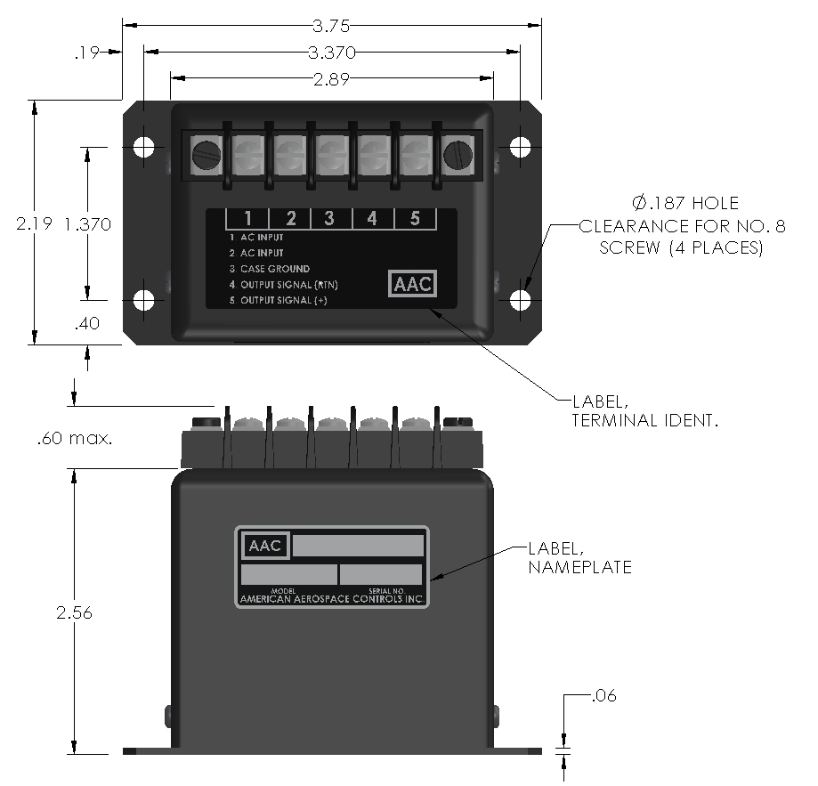
Drawing Number Rev.

700-105 L
AAC

